EQUATOR RESOLUTION
Institutional Mediation, Conciliation & Arbitration
www.equatorresolution.com · An Infrabyx Group Venture

Financial & Loan Dispute Resolution
Platform Design, Legal Framework & Operating Blueprint
Resolving borrower–lender disputes, one-time settlements, cheque-bounce matters,
digital-lending grievances and recovery disputes — fast, fair, and enforceable.

Document  Version / Date  Prepared for  Regulatory basis  Classification  Companion assets | Master Blueprint — Financial & Loan Vertical  Version 1.0 · July 2026  Equator Resolution (Infrabyx Group)  Mediation Act 2023; RBI Integrated Ombudsman Scheme 2021; RBI Digital Lending Directions 2025; NI Act 1881; Arbitration Act 1996  Strictly Confidential — Internal & Advisory  Forms Pack · Developer Workbook · Diagrams · Calculators · Deck · Prototype

Important Notice, Scope & How to Use This Document
This Blueprint guides the build-out and operation of Equator Resolution's Financial & Loan Dispute Resolution vertical. It frames the opportunity, sets out the legal and regulatory framework for borrower–lender disputes in India, and specifies the platform, forms and procedure the product and operations teams will implement. Equator is a mediation, conciliation and (where a clause exists) arbitration provider; it complements the special forums — the Debts Recovery Tribunals, the RBI Ombudsman and the consumer commissions — by resolving the disputes and settlements that those forums do not, and by helping parties navigate to the right forum.
The legal content is layered: each area opens with a plain-language summary, then deeper analysis, with statutes and cases flagged in “Legal Basis” boxes and consolidated in the annexures. The law is stated as of July 2026, including the RBI Integrated Ombudsman Scheme, 2021, the RBI (Digital Lending) Directions, 2025, the Mediation Act, 2023, and the Bharatiya Nyaya Sanhita / Bharatiya Nagarik Suraksha Sanhita, 2023 where criminal provisions apply.
RISK / CAUTION
This document is not a substitute for case-specific legal advice. Equator is neutral; it does not represent borrower or lender and does not practise law. Recovery under SARFAESI and the DRT, and complaints to the RBI Ombudsman, are special statutory routes that Equator does not replace — it resolves the mediatable and arbitrable disputes and the settlements around them.

Document control & approval
Item | Detail
Version | 1.0 (July 2026)
Owner | Equator Resolution — Financial & Loan vertical
Legal review | [ ] Banking/finance counsel · [ ] Data-protection counsel (complete before go-live)
Approved by | ______________________ (Director) Date: ____________
Next review | On any RBI circular, Ombudsman/Digital-Lending update, or amendment of the cited laws

LEGAL BASIS
Law as at July 2026. Verify RBI circulars, the Ombudsman Scheme and Digital Lending Directions, and case citations against the official texts before relying on them.

Table of Contents
This document uses Word heading styles. Open in Microsoft Word and choose “Update Field” on the entry below to generate a clickable, page-numbered contents list.
Right-click and choose “Update Field” to build the Table of Contents.

PART A
Strategic Overview
1. Executive Summary
Equator Resolution turns India's largest category of everyday disputes — money owed between borrowers and lenders — into a fast, fair, enforceable settlement process, and gives NBFCs and banks a dispute-resolution engine embedded in their loan agreements.
Every loan carries the seed of a dispute. India's booming NBFC and digital-lending sectors originate millions of loans, and a share of them end in default, disagreement, harassment complaints or dishonoured cheques. The traditional responses — years in civil court, the DRT for large secured debts, or a cheque-bounce prosecution — are slow, adversarial and clog the system; the cheque-bounce docket alone runs to millions of pending cases. The Mediation Act, 2023 changed the economics: a mediated settlement is now enforceable as a court decree, the RBI's grievance and Ombudsman architecture channels borrower complaints, and the Supreme Court actively encourages mediation, compounding and Lok Adalat settlement of cheque-bounce and recovery matters.
Equator is built for this. A borrower or a lender can commence online; the platform triages the matter to the right mechanism — conciliation/mediation and one-time settlement (OTS) for recovery disputes, the NI-138 mediation-to-compounding route for dishonoured cheques, arbitration where a loan agreement so provides, and guided referral to the RBI Ombudsman or DRT where those special forums apply. Money moves through escrow so a settlement is honoured and a No-Dues/NOC issued; the outcome is enforceable; and the whole journey runs online with AI assistance. For lenders, Equator's clause-insertion programme embeds Equator in loan agreements, creating a self-replenishing pipeline.
1.1 What Equator offers the parties
- For borrowers: a faster, fairer path than court; help navigating RBI grievance/Ombudsman routes; protection from harassment; a clean, recorded settlement and NOC.
- For lenders: quicker recovery through mediated OTS; lower cost than DRT/litigation; RBI-compliant grievance & dispute resolution; embedded clause pipeline.
- Speed & finality: settlements enforceable as decrees (s.27); Lok Adalat awards final and executable; time-bound process.
- Cheque-bounce resolution: mediation to compounding (s.147) — closing NI-138 matters without years of trial.
- Secured money: escrow releases the settlement against a No-Dues/NOC, protecting both sides.

2. The Opportunity
2.1 A vast, under-served dispute pool
India's credit economy generates disputes at enormous scale: NBFC and digital-lending growth multiplies borrower–lender friction; dishonoured-cheque prosecutions under Section 138 are among the most numerous cases in the country; and recovery, harassment and grievance complaints are rising with digital lending. The courts and the DRT cannot absorb this volume, and most of it is fundamentally about money and settlement, not principle — precisely the terrain where mediation and one-time settlement outperform adjudication.
2.2 Regulatory tailwinds
Four regulatory currents create Equator's opening. The Mediation Act, 2023 makes a mediated settlement enforceable as a decree. The RBI Integrated Ombudsman Scheme, 2021 and the RBI (Digital Lending) Directions, 2025 mandate grievance-redressal machinery in every regulated entity and lending service provider, and give borrowers a clear escalation path — a demand for structured, fair dispute resolution that Equator can serve. The Supreme Court and the RBI actively encourage settlement of cheque-bounce and recovery matters through mediation, compounding and Lok Adalat, and the RBI's 2023 compromise-settlement framework legitimises OTS. And the group's clause-insertion strategy — naming Equator in NBFC, bank and fintech loan agreements — turns every future loan into a potential Equator case.
COMPLIANCE NOTE
Equator positions as a neutral Mediation Service Provider and conciliation/arbitration institution for financial disputes, complementing (not competing with) the RBI Ombudsman and the DRT, and helping regulated entities meet their grievance-redressal obligations.

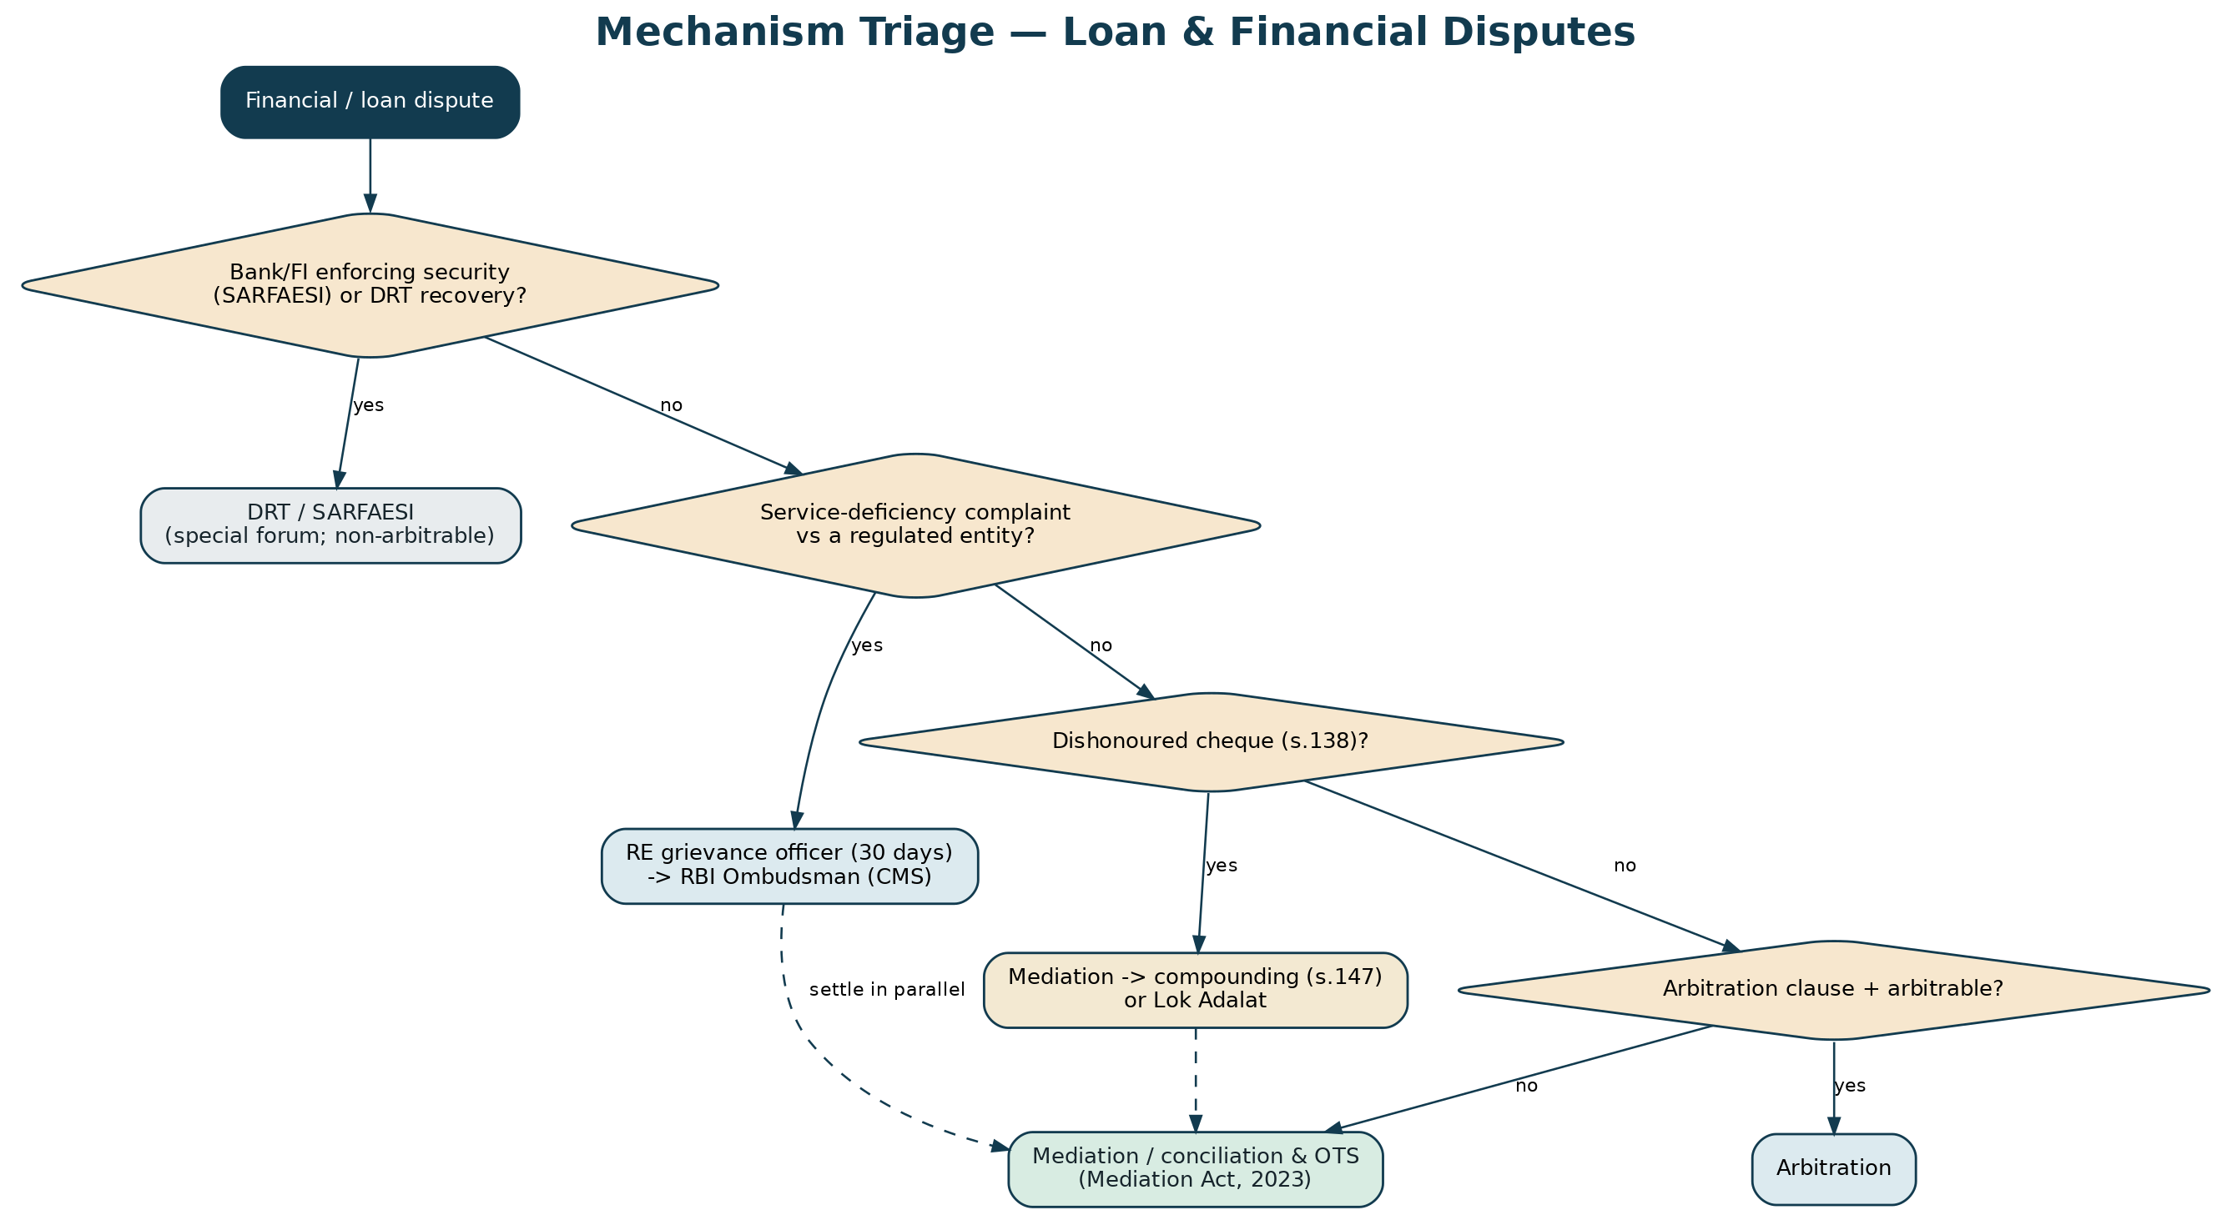
Figure 1 — Every financial dispute is triaged to the right route: special forum, or Equator mediation/arbitration/settlement.
3. Vision, Positioning & Guiding Principles
Equator's financial vertical promises resolutions that are faster, fairer and enforceable, and a responsible process that protects borrowers from harassment while giving lenders a real recovery path. Its principles: neutrality; fair treatment of the borrower (consistent with the RBI Fair Practices Code and consumer-protection norms); settlement over adjudication where money is the real issue; confidentiality; enforceability; regulatory alignment with the RBI framework; and data protection for sensitive financial data.
4. How Equator Works
Equator is the institution that administers the resolution: it maintains the panel of mediators, conciliators and arbitrators; publishes the rules and fee schedule; runs the case-management platform; serves notices; safeguards documents and settlement funds in escrow; and issues the settlement, consent award or closure. The neutral conciliates, mediates or arbitrates; the case manager drives the file; the parties — borrower and lender, and their representatives — participate through secure logins. Equator complements the RBI Ombudsman and the DRT: it resolves the mediatable disputes and the settlements those forums leave open, and guides parties to the correct forum where a matter is reserved.

PART B
The Legal & Regulatory Framework
5. Governing-Route Landscape: Which Mechanism Applies
PRACTICAL SUMMARY
Financial disputes flow down several channels, and intake's first job is to pick the right one: mediation/conciliation & OTS for recovery and contractual disputes; the RBI Ombudsman for service-deficiency complaints against regulated entities; NI-138 mediation/compounding for dishonoured cheques; arbitration where the loan agreement so provides and the matter is arbitrable; and the DRT/SARFAESI special forum for banks enforcing security. Some routes run in parallel.

The route is chosen from the nature of the dispute, the parties and the documents. A bank or financial institution enforcing a security interest uses SARFAESI and the DRT — a special forum, and such disputes are non-arbitrable. A borrower's complaint of deficiency in service by a regulated entity is first raised with the entity's grievance officer and, if unresolved in 30 days, escalated to the RBI Integrated Ombudsman. A dishonoured cheque is a Section 138 matter that can be settled through mediation and closed by compounding or in a Lok Adalat. An ordinary loan or contractual recovery dispute can be mediated (with a one-time settlement) or arbitrated if the agreement so provides. Equator's taxonomy captures these facts at intake and routes the matter — resolving what it can and guiding to the correct forum what it cannot.
Route | When it applies | Governing framework
Mediation / conciliation & OTS | Recovery / contractual loan disputes; settlement | Mediation Act, 2023; RBI compromise-settlement framework
RBI Ombudsman | Deficiency-in-service complaint vs a regulated entity | RBI Integrated Ombudsman Scheme, 2021
NI-138 (cheque bounce) | Dishonoured cheque | NI Act, 1881 ss.138, 147; SC guidelines; Lok Adalat
Arbitration | Arbitration clause + arbitrable dispute | Arbitration & Conciliation Act, 1996
DRT / SARFAESI | Bank/FI enforcing security / recovering debt | SARFAESI 2002; RDDBFI 1993 (non-arbitrable)
Consumer commission | Borrower as consumer; deficiency | Consumer Protection Act, 2019 (with mediation)
Lok Adalat | Any compromisable money matter | Legal Services Authorities Act, 1987

Table 1 — Route selection for financial & loan disputes.
6. RBI Grievance Redressal & the Integrated Ombudsman Scheme, 2021
PRACTICAL SUMMARY
If a customer has a complaint against a bank, NBFC or digital lender — wrong charges, mis-selling, harassment, a service failure — they first complain to the entity; if it isn't resolved in 30 days, or the reply is unsatisfactory, they escalate free of cost to the RBI Ombudsman via the online CMS portal. Equator helps borrowers use this route and mediates the underlying money dispute in parallel.

The RBI Integrated Ombudsman Scheme, 2021 (‘One Nation, One Ombudsman’) consolidated the earlier Banking, NBFC and Digital-Transactions ombudsman schemes into a single, cost-free redress mechanism for deficiency in service by RBI-regulated entities. A complaint lies to the Ombudsman where the regulated entity has rejected the complaint, replied unsatisfactorily, or not replied within 30 days. Complaints are filed online at the RBI Complaint Management System (cms.rbi.org.in). This is a grievance route, not a general dispute-resolution forum: it addresses service deficiency, not the merits of a contractual recovery dispute. Equator's role is to help borrowers navigate it and to mediate the underlying dispute (for example, a disputed charge or an OTS) so that the money issue is actually resolved.
LEGAL BASIS
RBI Integrated Ombudsman Scheme, 2021 (effective 12 November 2021), integrating the Banking Ombudsman Scheme 2006, the NBFC Ombudsman Scheme 2018 and the Ombudsman Scheme for Digital Transactions 2019; cost-free; 30-day escalation; CMS portal. Regulated entities of a specified size must also have an Internal Ombudsman.

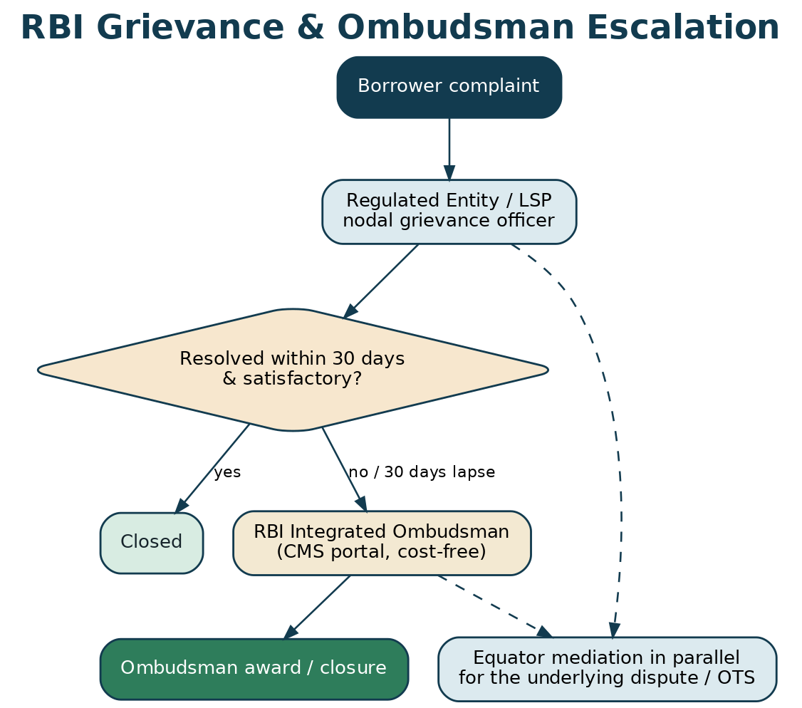
Figure 2 — RBI grievance and Ombudsman escalation, with Equator mediating in parallel.
7. Digital Lending (RBI Directions, 2025)
PRACTICAL SUMMARY
Digital loans (app-based, BNPL, instant credit) have their own RBI rulebook, tightened in 2025: clear up-front disclosure (a Key Fact Statement), a cooling-off period, no hidden charges, and a named grievance officer at the lender and the lending app — with escalation to the RBI Ombudsman. Disputes here are a fast-growing Equator segment.

The RBI (Digital Lending) Directions, 2025 (issued 8 May 2025) reset the rules for app-based and platform lending to protect borrowers and increase oversight. Every Regulated Entity (RE) and Lending Service Provider (LSP) with a borrower interface must designate a nodal grievance-redressal officer for digital-lending complaints; if a complaint is not resolved within 30 days, the borrower may escalate to the RBI Ombudsman. The Directions require a Key Fact Statement, a cooling-off/look-up period, transparency on charges and recovery, and controls on data and conduct. Common disputes — hidden charges, mis-selling, coercive recovery, wrong credit-bureau reporting, and default/settlement — are squarely mediatable, and Equator provides both the grievance-navigation help and the settlement forum.
LEGAL BASIS
RBI (Digital Lending) Directions, 2025 (8 May 2025): nodal grievance officer for RE & LSP; Key Fact Statement; cooling-off period; transparency and data/recovery controls; escalation to the RBI Ombudsman. Read with the RBI Fair Practices Code for NBFCs.

Figure 3 — The digital-lending grievance path and Equator's mediation of the underlying dispute.
8. Cheque Bounce — Section 138 of the Negotiable Instruments Act
PRACTICAL SUMMARY
A bounced cheque is a criminal offence (Section 138) — but the courts treat it as compensatory, and actively push parties to settle. A settlement can close the case by compounding (Section 147) or in a Lok Adalat (whose award is a final decree). This is one of Equator's highest-volume, fastest-win segments.

Section 138 of the NI Act criminalises the dishonour of a cheque for insufficiency of funds, where the drawer fails to pay within 15 days of a demand notice served within 30 days of dishonour. Although criminal, the offence is primarily compensatory, and Section 147 makes it compoundable. The Supreme Court has repeatedly encouraged early settlement: in Damodar S. Prabhu v. Sayed Babalal it set a graded-cost scale to reward early compounding (rising from a small percentage of the cheque amount before evidence to higher percentages on appeal), and in Indian Bank Association v. Union of India it issued guidelines for speedy trial and settlement, expressly promoting mediation and Lok Adalats. High Courts have confirmed that a Section 138 matter may lawfully be referred to mediation. A settlement reached at Equator is carried to compounding before the court, or recorded in a Lok Adalat (whose award has the force of a civil-court decree, final and executable), with the payment secured through escrow and released on closure.
LEGAL BASIS
NI Act, 1881: s.138 (dishonour offence), s.147 (compoundable). Damodar S. Prabhu v. Sayed Babalal H., (2010) 5 SCC 663 (graded compounding costs); Indian Bank Association v. Union of India, (2014) 5 SCC 590 (speedy-trial guidelines; encourage compounding/mediation/Lok Adalat); Meters & Instruments v. Kanchan Mehta, (2018) 1 SCC 560 (compensatory nature; closure on payment). Lok Adalat award: Legal Services Authorities Act, 1987 s.21 (decree; no appeal).

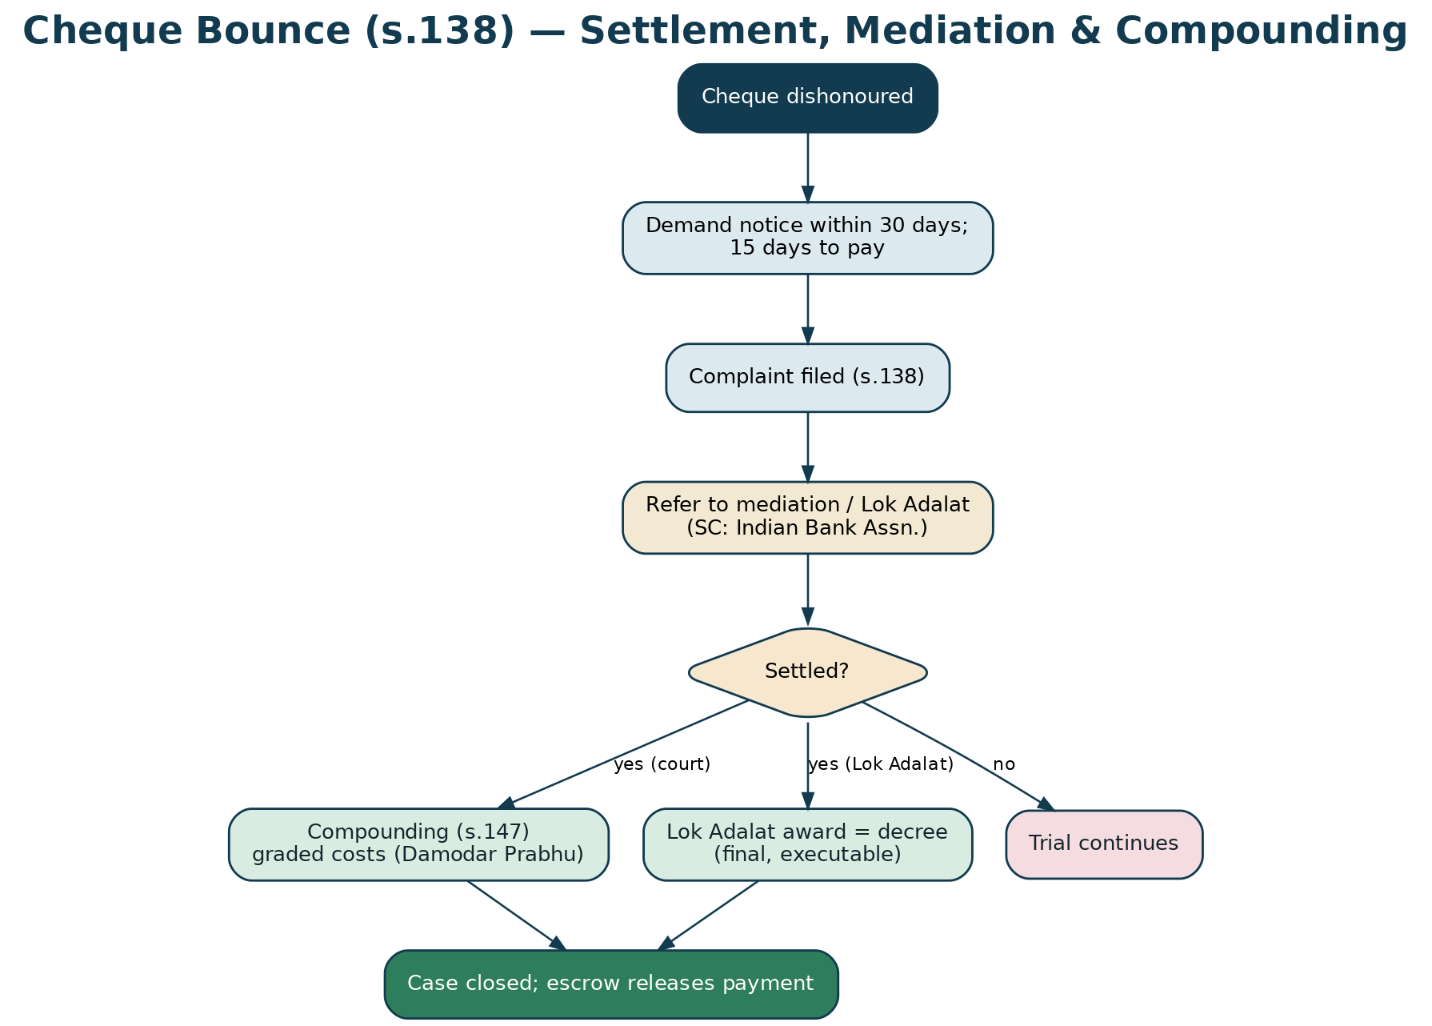
Figure 4 — Cheque-bounce settlement through mediation to compounding or Lok Adalat.
9. SARFAESI, the DRT & Arbitrability of Loan Disputes
PRACTICAL SUMMARY
When a bank or FI enforces security (mortgaged property, hypothecated assets) or recovers a large debt, that goes to the DRT under special laws — and such disputes are not arbitrable and not for Equator to decide. But ordinary loan/contractual recovery disputes (especially by NBFCs and fintechs) can be mediated or arbitrated. Getting this line right at intake is essential.

Two special statutes reserve bank/FI recovery to a dedicated forum. The SARFAESI Act, 2002 lets a secured creditor enforce its security interest without court intervention (Section 13), with the borrower's remedy lying to the Debts Recovery Tribunal (DRT) and then the DRAT. The RDDBFI Act, 1993 establishes the DRT for recovery of debts due to banks and financial institutions above the statutory threshold. Because these are special forums protecting a public/statutory scheme, disputes within their domain are non-arbitrable (Vidya Drolia; and specifically for SARFAESI, the special-forum bar). Equator therefore screens these out and guides parties to the DRT — while taking the large, under-served field of NBFC, fintech, personal, vehicle, gold, MSME and unsecured loan disputes, and co-lending/partnership disputes, which are arbitrable and eminently mediatable, and the settlements that even a DRT matter ultimately needs.
LEGAL BASIS
SARFAESI Act, 2002 (s.13 enforcement; s.17 DRT appeal); RDDBFI Act, 1993 (DRT/DRAT). Non-arbitrability of the special-forum recovery domain: Vidya Drolia v. Durga Trading, (2021) 2 SCC 1; SARFAESI/DRT bar recognised in the case law. Ordinary loan/contractual disputes remain arbitrable.

10. Mediation, Conciliation & One-Time Settlement
PRACTICAL SUMMARY
Most loan disputes are really about how much, by when — perfect for mediation and a one-time settlement (OTS): a negotiated figure (often with a waiver of part of the interest/penalty), paid in one shot or on a schedule, in exchange for closing the account and a No-Dues/NOC. The RBI's 2023 framework legitimises such compromise settlements.

Equator's core offering is conciliation/mediation leading to a settlement. For a defaulted or disputed loan, the mediator helps the parties agree an OTS — a settlement amount, any waiver of accrued interest or penal charges, and a payment schedule — recorded in a Mediated Settlement Agreement that is enforceable as a decree under Section 27 of the Mediation Act. The RBI's compromise-settlement and technical-write-off framework (2023) expressly permits regulated entities to enter board-approved compromise settlements, giving lenders the regulatory comfort to settle. Where a commercial loan suit of specified value is contemplated without an arbitration clause, the mandatory pre-institution mediation under Section 12A of the Commercial Courts Act may also apply. The settlement money is routed through escrow and released against the No-Dues/NOC, and the borrower's credit-bureau record is updated on closure.
LEGAL BASIS
Mediation Act, 2023 (s.19 MSA; s.20 registration; s.27 enforceable as a decree); RBI Framework for Compromise Settlements and Technical Write-offs, 2023 (board-approved compromise settlements permitted, including subject to conditions for wilful defaulters); Commercial Courts Act s.12A where applicable.

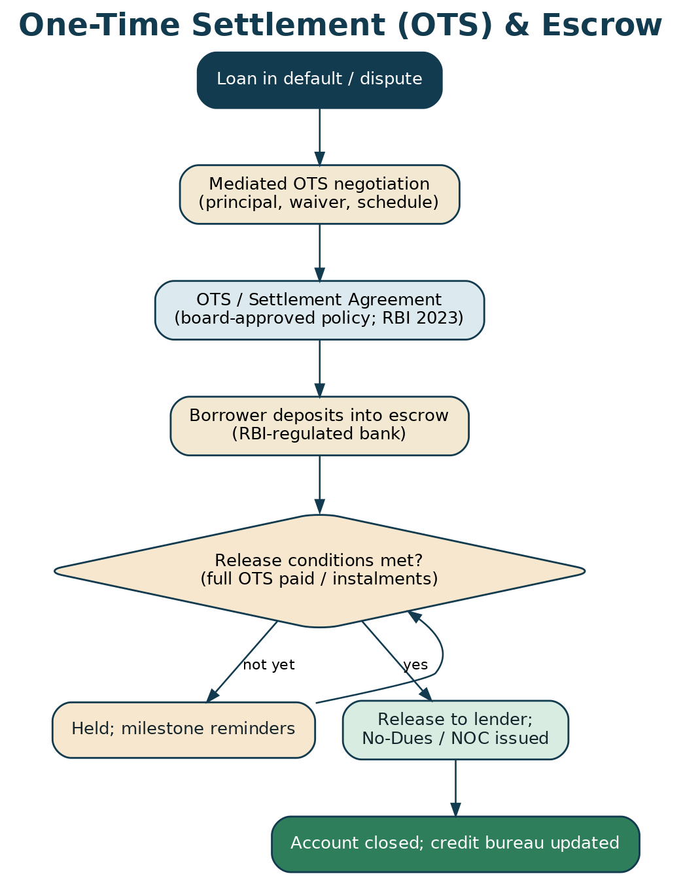
Figure 5 — One-time settlement negotiated in mediation and secured through escrow.
11. Consumer Protection & Recovery-Agent Conduct
PRACTICAL SUMMARY
Borrowers are often consumers with rights, and lenders must follow the RBI's Fair Practices Code — including limits on how recovery agents may behave. Harassment is not allowed. Equator handles harassment complaints and consumer-style grievances, and channels them to settlement or the right forum.

A borrower who is a consumer may complain of deficiency in service or unfair trade practice to the consumer commissions under the Consumer Protection Act, 2019, which itself provides for mediation. Separately, the RBI Fair Practices Code and its guidelines govern lender and recovery-agent conduct: agents may not use intimidation, harass, or contact borrowers at odd hours, and the courts have held lenders liable for coercive recovery. Equator treats a harassment complaint as both a grievance to be escalated (to the lender's grievance officer and, if needed, the RBI Ombudsman or the police) and a dispute to be settled (mediating the underlying debt while protecting the borrower). This dual handling — remedy plus resolution — is a distinctive Equator strength.
LEGAL BASIS
Consumer Protection Act, 2019 (consumer complaints; mediation). RBI Fair Practices Code for NBFCs and the outsourcing/recovery-agent guidelines (conduct norms; no harassment). Coercive recovery may attract civil and criminal liability.

12. Lok Adalat & Enforcement
PRACTICAL SUMMARY
The Lok Adalat is the fastest way to close a money matter by settlement — its award is a civil-court decree, final, with no appeal. Equator's settlements can be taken to a Lok Adalat, or registered as a Mediated Settlement Agreement, or (in arbitration) recorded as a consent award — all enforceable.

Equator's outcomes are enforceable through several complementary routes. A Mediated Settlement Agreement is enforceable as a decree (Section 27, Mediation Act). A Lok Adalat award — under the Legal Services Authorities Act, 1987 — is deemed a decree of a civil court, is final and binding, and is executable under the CPC, making it ideal for closing cheque-bounce and recovery settlements at scale. Where the matter was arbitrated, a consent award or award is enforceable as a decree (Section 36 of the Arbitration Act). And a lender's DRT proceeding ends in a recovery certificate executed by the Recovery Officer. Equator's escrow releases the settlement funds against the closure and the No-Dues/NOC.
LEGAL BASIS
Legal Services Authorities Act, 1987 (s.19–22 Lok Adalat; s.21 award deemed a civil-court decree, final, no appeal). Mediation Act s.27; Arbitration Act s.36; RDDBFI recovery certificate.

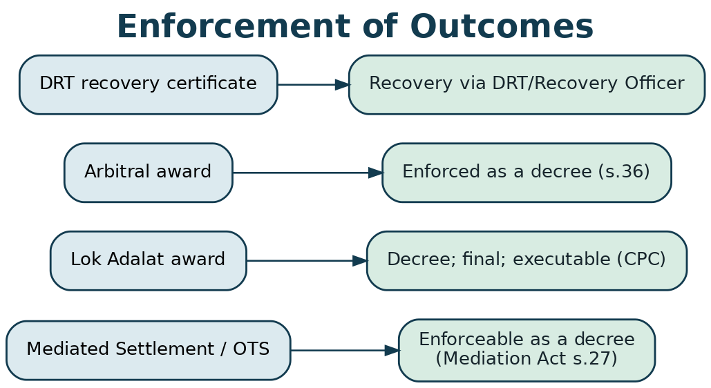
Figure 6 — Enforcement routes: MSA, Lok Adalat award, arbitral award, and DRT recovery certificate.

PART C
The Platform & Procedure
13. Dispute Taxonomy & Dropdown Architecture
PRACTICAL SUMMARY
The menu the website shows a borrower or lender: dispute type → loan type → lender type → amount → relief, plus whether there's an arbitration clause. Selecting them attaches the right law, route, forms and neutral. The machine-readable version is in the Developer Workbook.

Intake captures the dispute type, the loan/product type, the lender type, the amount, and the relief sought, and runs the mechanism triage. This drives the applicable-law checklist, the forms, and (where relevant) guided referral to the RBI Ombudsman or the DRT.
Dispute type | Representative issues | Usual route
Loan default & recovery | Non-payment, acceleration, penal charges | Mediation & OTS / arbitration (if clause)
One-time settlement (OTS) | Compromise amount, waiver, schedule | Mediation / conciliation
Cheque bounce (NI-138) | Dishonoured cheque; demand notice | Mediation → compounding / Lok Adalat
Wrong / excess charges | Hidden fees, penal interest, mis-charging | RBI grievance / Ombudsman + mediation
Digital-lending grievance | App loans, BNPL, KFS, data/recovery | Nodal officer / Ombudsman + mediation
Recovery-agent harassment | Coercion, odd-hour contact, intimidation | Grievance/complaint + mediation of debt
Mis-selling / unfair practice | Insurance bundling, undisclosed terms | Consumer / Ombudsman + mediation
Credit-bureau dispute | Wrong default reporting (CIBIL etc.) | Grievance + mediated correction on settlement
Guarantee / co-borrower | Guarantor liability, contribution | Mediation / arbitration
Co-lending / fintech partnership | RE–LSP disputes, revenue share | Arbitration / mediation
Secured-debt recovery (bank/FI) | Mortgage/hypothecation enforcement | DRT / SARFAESI (referral; non-arbitrable)

Table 2 — Financial dispute-type → issues → route (full schema in the Developer Workbook).
13.1 Key dropdowns & options
Also exposed: loan type (personal, vehicle, home, gold, education, business/MSME, credit card, BNPL, microfinance, P2P); lender type (bank, NBFC, HFC, fintech/LSP, microfinance, P2P platform, private); amount band; arbitration clause?; security? (secured/unsecured); relief (waiver/OTS, refund of charges, stop harassment, credit-bureau correction, restructuring, No-Dues/NOC, recovery of amount, compounding of cheque case); and initiated by (borrower / lender).
14. User Roles & Access Management
Role | Who | Core permissions
Borrower | Individual / business borrower or guarantor | File dispute/complaint; upload loan docs; propose OTS; join sessions; e-sign; fund/receive escrow
Lender | Bank / NBFC / fintech / LSP | File recovery/settlement; respond; upload statements; approve OTS (board policy); e-sign; escrow
Neutral (mediator/conciliator/arbitrator) | Empanelled neutral | Conduct sessions; draft settlement/award; issue reports
Case Manager | Equator officer | Screen & triage; serve notices; enforce timeline; manage documents, escrow & NOC; support neutral
Representative / advocate | For either party | Represent on authorisation; attend sessions; assist with court/Lok Adalat/compounding
Grievance liaison (lender) | RE/LSP nodal officer | Coordinate grievance handling and settlement approval
Administrator | Equator admin | Panel; audit logs; compliance & DPDP; no access to caucus content
Escrow Officer | Equator finance + partner bank | Escrow set-up; funding; conditional release; KYC/PMLA

Table 3 — Roles and least-privilege access.
15. Onboarding & Registration (KYC / KYB)
PRACTICAL SUMMARY
Borrowers verify identity (KYC); lenders verify as a business (KYB). The platform captures the loan and the dispute, records DPDP consent, and triages to the right route.

- Dispute Explorer (no login): AI-assisted self-assessment — the right route, the borrower's rights, and a likely settlement range.
- Account & verification: individual KYC (Aadhaar/PAN e-KYC) for borrowers; KYB (CIN/GSTIN, authority) for lenders.
- DPDP consent: itemised notice and consent for processing financial data; special care for sensitive data.
- Dispute intake: dispute type → loan/lender type → amount → relief; upload the loan agreement, statements and notices.
- Route triage & agreement to the Rules: the platform runs the mechanism triage; the parties accept the applicable rules and fees and e-sign.
- Screening & registration: the case manager validates, assigns a case number, and opens the file (and flags any special-forum referral).

16. End-to-End Workflow
A financial matter runs on one of several tracks — conciliation/mediation & OTS, NI-138 mediation-to-compounding, arbitration (where a clause applies), or a guided referral to the RBI Ombudsman or the DRT — sharing common intake, escrow, e-execution and closure. The commonest path is a mediated one-time settlement, funded through escrow and released against a No-Dues/NOC, with the borrower's credit record updated on closure.
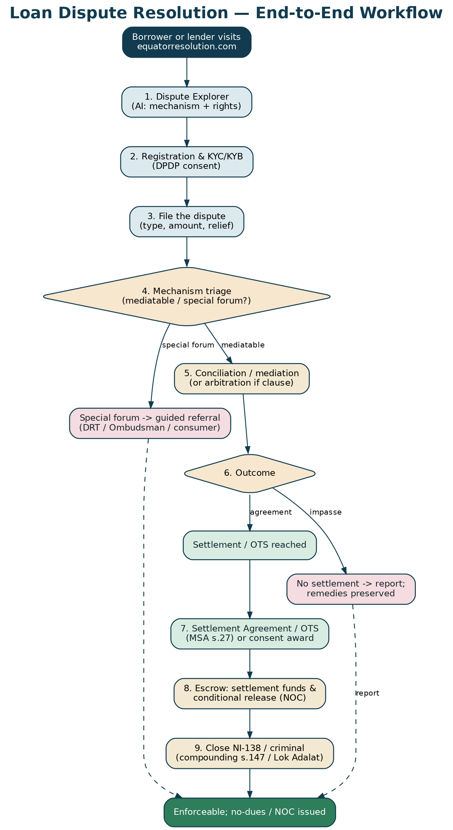
Figure 7 — The end-to-end loan-dispute workflow, from intake to No-Dues/NOC.
17. Initiation, Response & Either-Party Access
Equator is symmetrical: either the borrower or the lender may commence. A lender may file to recover or to offer an OTS; a borrower may file to dispute charges, settle, stop harassment, correct a credit record, or restructure. The other party is formally invited to respond. Because a borrower is often the more vulnerable party, the process is designed to be accessible and fair — plain language, vernacular support, protection from coercion, and clear information about rights and the RBI grievance routes.
18. Neutral Selection & Empanelment
Equator maintains a panel of conciliators, mediators and arbitrators with banking/finance experience (former bankers, recovery and finance lawyers, retired officers, trained mediators), filterable by language, city, product expertise, mode and fee. Appointment follows party autonomy or, failing agreement, institutional appointment; every neutral is conflict-checked and signs a disclosure before appointment. For high-volume, lower-value matters (cheque bounce, small loans), a fast, single-neutral, online process is the norm.
19. Conducting Proceedings — The Case Manager Playbook
Stage | Case-manager actions | Key forms / outputs
Intake & triage | KYC/KYB & consent; mechanism triage; register; flag special-forum referral | Screening; case record
Notice & response | Serve notice on the other party; track response | F-L03 Notice; F-L05 Response
Neutral appointment | Filter panel; appoint; conflict check & disclosure | F-L06 selection/disclosure
Sessions | Convene conciliation/mediation (online); compute settlement options | Session log; settlement worksheet
Settlement | Draft OTS/MSA or consent award; set up escrow & NOC | F-L07 OTS; F-L11 Escrow
Cheque / criminal | Sequence NI-138 compounding / Lok Adalat | F-L08 NI-138 memo
Closure | Release escrow on No-Dues; update credit bureau; issue NOC | F-L15 Enforcement; F-L16 Closure

Table 4 — Case-manager operating rhythm.
RISK / CAUTION
The case manager must protect the borrower from coercion and give no legal advice, and must correctly route special-forum matters (SARFAESI/DRT, Ombudsman) rather than purporting to resolve them.

20. Time-Bound Procedure & Service Levels
Milestone | Target | Basis
Case registration after complete filing | 1–2 working days | Equator SLA
Notice served on the other party | ≤ 3 working days | Equator SLA
RE grievance window (Ombudsman route) | 30 days | RBI Ombudsman Scheme
First conciliation/mediation session | ≤ 14 days of appointment | Equator SLA
Settlement / OTS | Typically ≤ 60 days | Equator SLA
Mediation completion | Up to 120 days (+60) | Mediation Act, 2023
NI-138 compounding / Lok Adalat | On next Lok Adalat / court date | SC guidelines
Escrow release on No-Dues | T+7 of NOC / condition | Escrow instruction

Table 5 — Statutory limits and Equator service levels.
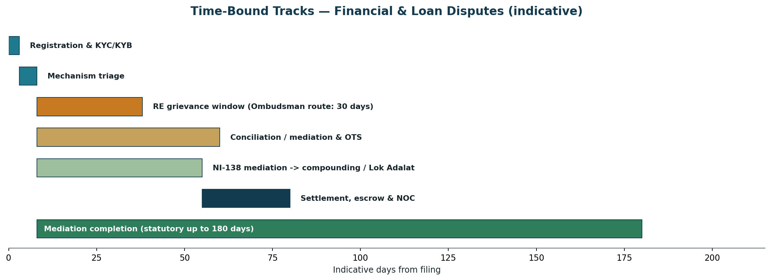
Figure 8 — Indicative time-bound tracks for financial & loan disputes.
21. Settlement, OTS & Consent Award
The resolution is recorded in the right instrument: a one-time settlement / Mediated Settlement Agreement (enforceable as a decree, s.27); a Lok Adalat award (a final civil-court decree) for cheque-bounce and recovery matters; or, where arbitrated, a consent award (s.30) enforceable as a decree (s.36). The instrument records the settlement amount, any waiver, the schedule, the release of security or cheque, the No-Dues/NOC, and the credit-bureau correction the lender will make on closure.
22. Enforcement Support
Equator supports realisation: taking the settlement to a Lok Adalat or registering the MSA; coordinating NI-138 compounding; enforcing an arbitral award (s.36); and releasing escrow against the No-Dues/NOC. It also ensures the lender updates the credit bureau (CIBIL/CRIF/Experian) so the borrower's record reflects the closed/settled status.
23. The Escrow Mechanism
PRACTICAL SUMMARY
A neutral holding account for the settlement money. The borrower deposits the OTS amount; the escrow agent releases it to the lender only against a No-Dues/NOC and the return of any security/cheque — so the borrower doesn't pay and remain 'in default', and the lender is assured of payment.

Escrow solves the classic borrower–lender trust gap. Equator arranges a tripartite escrow with a regulated bank as agent (Indian Contract Act; KYC/PMLA-compliant). The borrower deposits the settlement sum (one-shot or instalments); release is conditional on the lender issuing the No-Dues/NOC, returning the original documents/security and the dishonoured cheque, and updating the credit bureau. Each movement is receipted and audit-logged, with a defined fallback if a condition is not met.
Figure 9 — Escrow releases the settlement against the No-Dues/NOC.
24. Permutations & Scenarios — the If / Then Logic
If this circumstance… | …then Equator does this
Bank/FI enforcing security (SARFAESI) / large DRT recovery | Non-arbitrable special forum — guide to the DRT; mediate any settlement the parties want.
Service-deficiency complaint vs a regulated entity | Help escalate to the RE grievance officer and, after 30 days, the RBI Ombudsman; mediate the money dispute in parallel.
Dishonoured cheque (s.138) | Mediate; carry the settlement to compounding (s.147) or a Lok Adalat; release escrow on closure.
Ordinary loan/contractual dispute (NBFC/fintech) | Mediate to an OTS, or arbitrate if the agreement so provides.
Recovery-agent harassment | Treat as a grievance (escalate) AND mediate the underlying debt; protect the borrower.
Digital-lending grievance (app loan/BNPL) | Grievance to the nodal officer/Ombudsman; mediate charges/settlement; check KFS & cooling-off.
Wrong credit-bureau reporting | Build the correction into the settlement; the lender updates the bureau on closure.
Borrower is a consumer | Consider the consumer commission (with mediation); or settle at Equator.
Guarantor / co-borrower involved | Join them; allocate liability and contribution in the settlement.
Borrower can't pay in one shot | Structure instalments with escrow security and a review mechanism.
Lender needs board approval for OTS | Sequence the settlement to the lender's compromise-settlement policy (RBI 2023).
No settlement | Issue a report; preserve the parties' remedies (court/DRT/Ombudsman/arbitration).

Table 6 — Principal branch conditions and Equator's programmed response.

PART D
Governance, Commercials & Operations
25. Forms Register
All forms are reproduced in full in Part H and delivered as individual documents in the archived Forms Pack folder. The Developer Workbook carries the field-level schema for each.
Ref | Form | Used at
F-L01 | Onboarding, KYC/KYB & DPDP Consent | Registration
F-L02 | Request for Resolution (Loan Dispute) | Commencement
F-L03 | Notice to the Other Party | Notice
F-L04 | Borrower Grievance / Complaint | Grievance route
F-L05 | Response | Response
F-L06 | Neutral Selection & Disclosure | Appointment
F-L07 | One-Time Settlement (OTS) Agreement | Settlement
F-L08 | NI-138 Settlement & Compounding Memorandum | Cheque bounce
F-L09 | Recovery-Agent Harassment Complaint | Harassment
F-L10 | Digital-Lending Grievance | Digital lending
F-L11 | Escrow Instruction & Release Schedule | Settlement
F-L12 | Consent Award / Mediated Settlement Agreement | Settlement
F-L13 | Statement of Claim (Loan) — arbitration | Arbitration
F-L14 | Lok Adalat Referral / Joint Compromise Memo | Lok Adalat
F-L15 | Enforcement & No-Dues / NOC Checklist | Closure
F-L16 | Case Closure Report | Closure
F-L17 | Agreement to Mediate & Confidentiality | Pre-mediation
F-L18 | Costs & Fee Statement | Billing
F-L19 | Model Loan-Agreement ADR Clause | Clause insertion
F-L20 | Application for Time Extension | Sessions

Table 7 — Financial forms register (full text in Part H).
26. Fees & Commercials
Financial-dispute fees are kept low and volume-friendly, reflecting many small-value matters (cheque bounce, personal loans) alongside larger recovery disputes. The structure: a modest registration fee, a per-session or flat mediation fee (concessional for small/consumer matters), an escrow-handling fee, and — for institutional lenders — subscription/volume pricing under the clause-insertion programme. A settlement calculator gives instant estimates.
Component | Basis | Indicative
Registration fee | One-time, per case | ₹500–2,000 by value band
Mediation / conciliation fee | Flat or per session; concessional for small matters | ₹2,000–15,000
Arbitration (if clause) | Per Fourth Schedule / schedule | Ad valorem
Escrow handling | % of amount held / flat | Per bank tariff
Institutional subscription | Per lender volume tier (clause-insertion) | Negotiated
Consumer / indigent concession | Reduced / waived | Means-based

Table 8 — Fee architecture (confirm against Equator's published tariff).
27. Risk, Ethics & Compliance Register
Risk | Impact | Mitigation
Resolving a special-forum matter (SARFAESI/DRT/Ombudsman) | Void/ineffective; jurisdiction | Triage & route; do not purport to decide special-forum matters
Borrower coercion / unfair settlement | Void settlement; harm; reputational | Fair-process safeguards; no legal advice; right to withdraw; caucus
Non-compliance with RBI Fair Practices / recovery norms | Regulatory & reputational | Align process with RBI Code; handle harassment properly
Data breach (financial data) | DPDP penalties; harm | Encryption, access control, breach protocol, minimisation
Escrow / No-Dues mishandled | Financial loss; disputes | Regulated agent; conditional release on NOC; audit
Wrong credit-bureau outcome | Borrower harm | Bake correction into settlement; verify lender action
Cheque case not lawfully compounded | Settlement fails | Follow SC compounding process; Lok Adalat where apt
AI error / disguised advice | Harm; UPL | Guardrails; human-in-the-loop; information not advice

Table 9 — Principal risks and controls.
28. Implementation Roadmap
- Phase 1 (Months 1–3): publish rules & fee schedule; stand up intake, triage, KYC/KYB and case management; empanel finance-experienced neutrals; deploy the Forms Pack; build the OTS & interest calculators.
- Phase 2 (Months 3–5): escrow & No-Dues workflow; NI-138 compounding/Lok Adalat integration; digital-lending grievance handling; e-Sign/e-Stamp; supervised pilots with 2–3 NBFCs.
- Phase 3 (Months 5–8): RBI Ombudsman/DRT/Lok Adalat referral alignment; clause-insertion onboarding of NBFC/bank/fintech partners; credit-bureau integration.
- Phase 4 (Months 8–12): scale institutional partners and case volume; publish anonymised settlement data; expand to microfinance and P2P.

29. Key Performance Indicators
KPI | Definition | Target (Year 1)
Time to first session | Filing → first session | ≤ 14 days (median)
Settlement rate | Settled ÷ commenced | ≥ 60%
Cheque-bounce closure | NI-138 matters compounded/settled | ≥ 65%
Cycle time | Filing → settlement | ≤ 45 days (median)
Recovery for lenders | OTS realised via escrow | ≥ 90% of agreed
Borrower satisfaction / fairness | Post-case CSAT | ≥ 4.3 / 5
Escrow reliability | Releases to schedule | ≥ 99%
Clause-insertion partners | Lenders embedding Equator | ≥ 15 in Year 1
Credit-bureau correction compliance | Corrections completed on closure | 100%

Table 10 — Financial-vertical KPIs.

PART E
Strengthening Resolution & Global Best Practice
30. Global Best Practice in Financial Dispute Resolution
PRACTICAL SUMMARY
Mature markets resolve financial consumer disputes through ombudsman + ADR models — the UK's Financial Ombudsman Service, Australia's AFCA, and consumer-finance ADR in the US. Equator adopts the best of these — accessibility, free/low-cost redress, fairness to the consumer — within India's RBI Ombudsman and Mediation Act framework.

The global consensus on financial disputes favours accessible, low-cost, consumer-fair resolution. The UK Financial Ombudsman Service and Australia's AFCA provide free, binding redress for consumers against financial firms; US consumer-finance disputes use arbitration and mediation with consumer safeguards. India's own RBI Integrated Ombudsman mirrors this for grievances, and the Mediation Act and Lok Adalat system provide the settlement layer. Equator's design borrows the accessibility, plain-language and consumer-fairness of these systems, adds escrow-secured settlement and digital delivery, and aligns with NITI Aayog's ODR push and the UNCITRAL Technical Notes on ODR.
Model | Signature practice | What Equator adopts
UK FOS / Australia AFCA | Free, accessible, consumer-fair ombudsman ADR | Accessibility, plain language, borrower fairness
US consumer-finance ADR | Arbitration/mediation with consumer safeguards | Fair process; no coerced settlements
RBI Ombudsman (India) | Cost-free grievance redress | Complement it; mediate the underlying dispute
NITI Aayog / UNCITRAL ODR | Online, transparent, secure ODR | ODR-native, AI-assisted platform

Table 11 — Global best practice mapped to Equator's Indian implementation.
31. Getting Parties to the Table — the Clause-Insertion Engine
Equator's pipeline is built by being named in loan agreements. When an NBFC, bank or fintech embeds the Equator ADR/mediation clause (Form F-L19) in its standard loan documents, every future dispute under those loans can come to Equator — the group's flagship clause-insertion strategy, applied to lending. Court and Lok Adalat referrals, and the RBI grievance escalation, supply further volume. For borrowers, accessibility and fairness drive organic use and referrals.
32. Better Outcomes — Beyond Recovery
- Structured OTS: Waivers, instalments and escrow milestones that a borrower can actually meet — improving realisation.
- Credit-bureau correction: Baking the CIBIL/CRIF update into the settlement restores the borrower and closes the loop.
- Financial counselling & literacy: Signposting to debt-counselling and budgeting reduces relapse into default.
- Harassment resolution: Stopping coercive recovery while settling the debt — protecting the borrower and de-risking the lender.
- Bulk / portfolio settlement: Handling lenders' portfolios of small defaults efficiently through templated mediation and Lok Adalat.

33. Measuring Resolution Quality
Beyond settlement rate, Equator measures durability (settlements honoured; no re-default within 12 months), realisation (recovery for lenders), fairness (borrower satisfaction; no coercion), credit-record repair (corrections completed), and access (participation, time-to-first-session, concessional uptake). These feed a learning loop and the anonymised settlement bank.

PART F
Technology — AI, ODR, e-Sign, e-Stamp & Forum Integration
34. The AI-Assisted Loan Dispute Explorer
PRACTICAL SUMMARY
The AI front door for borrowers and lenders: it explains the right route (grievance/Ombudsman vs DRT vs mediation vs NI-138), the borrower's rights (RBI rules, recovery-agent conduct), estimates a settlement/OTS, and drafts the complaint or request — always as a reviewable draft, not legal advice.

The AI assistant is grounded on Equator's rules and the framework in this Blueprint. For a user it provides: route/mechanism guidance (Ombudsman, DRT, mediation, NI-138, arbitration, consumer, Lok Adalat); rights and options (RBI Fair Practices, recovery-agent limits, digital-lending protections); an OTS/settlement estimate; and drafting help for a borrower grievance, a request for resolution, or a statement of claim. For the case manager and neutral it drafts notices, computes settlement options and interest, and summarises documents — always under human control. It informs, it does not advise, and it is especially careful not to give a borrower or lender case-specific legal advice.
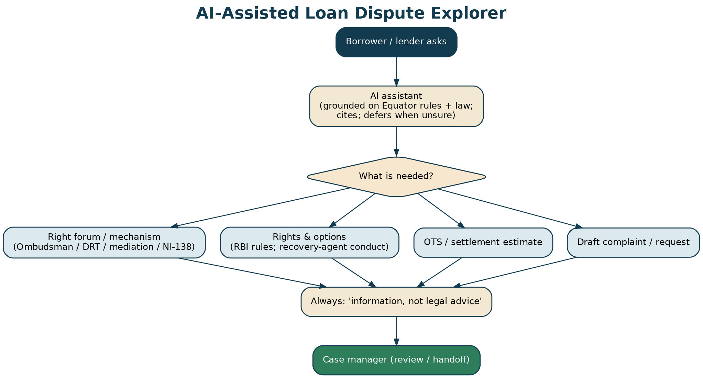
Figure 10 — The AI-assisted loan Dispute Explorer: route guidance, rights, OTS estimate, drafting.
35. AI Governance, Guardrails & Data Protection
- Information, not legal advice: General information + route guidance; prompts to consult counsel; no UPL.
- Human-in-the-loop: Every draft is reviewed and owned by a human.
- Neutrality & borrower fairness: Helps both sides; never coaches coercive recovery or an unfair settlement.
- Grounded & cited: Retrieval-augmented over Equator rules and this Blueprint; refuses/defers when unsure.
- Confidential by design: Within the confidentiality wall; per-party data isolation.
- DPDP-compliant: Consent; minimisation; no training on personal/financial data without consent; audit logs.

RISK / CAUTION
Financial AI risks: giving disguised legal/financial advice, enabling coercive recovery, and mishandling sensitive financial data. The guardrails target these; the AI defers to a human when unsure.

36. Online Dispute Resolution (ODR)
Equator is ODR-native: asynchronous exchange, secure video sessions with private caucus, a permissioned case room, and documents-only / fast tracks for high-volume small matters (cheque bounce, small loans). The design follows the UNCITRAL ODR Technical Notes and NITI Aayog's ODR push — ideal for the scale and geographic spread of financial disputes, and for low-bandwidth, mobile-first, vernacular access.
37. Paperless Filing & e-Signature
Every filing and settlement can be completed online and executed with Aadhaar e-Sign or DSC (IT Act, 2000, s.3A and Second Schedule), with an audit trail and Section 65B admissibility. This suits high-volume, remote, small-value financial matters especially well.
38. On-Platform Execution: e-Stamp & Registration
Settlement agreements are e-stamped on the platform (SHCIL) and, where applicable, registered (s.20). A Lok Adalat award needs no stamp duty. The result is an end-to-end digital journey — file, resolve, sign, stamp, close — with the No-Dues/NOC issued digitally.
39. Integration with Forums (Ombudsman, DRT, Lok Adalat, Courts)
Equator interoperates with the financial-dispute ecosystem: guided referral to the RBI Ombudsman (CMS) and the DRT where those forums apply; Lok Adalat scheduling to convert settlements into decrees; court referral and NI-138 compounding; and credit-bureau updates. Over time, consent-based status linkage keeps borrowers, lenders and forums on a single current picture.

PART G
Annexures
Annexure A — Consolidated Legal Authorities
Statutes & regulations
Instrument | Relevance
Mediation Act, 2023 | Mediation; MSA (s.19); registration (s.20); enforceable as a decree (s.27); s.12A interface
RBI Integrated Ombudsman Scheme, 2021 | Cost-free grievance redress vs regulated entities; 30-day escalation; CMS
RBI (Digital Lending) Directions, 2025 | Nodal grievance officer; KFS; cooling-off; transparency; escalation
RBI Fair Practices Code / recovery-agent guidelines | Lender & recovery-agent conduct; no harassment
RBI Framework for Compromise Settlements & Technical Write-offs, 2023 | Board-approved OTS/compromise settlements
Negotiable Instruments Act, 1881 | Cheque bounce (s.138); compoundable (s.147)
SARFAESI Act, 2002; RDDBFI Act, 1993 | Bank/FI security enforcement & DRT recovery (special forum; non-arbitrable)
Arbitration & Conciliation Act, 1996 | Arbitration of arbitrable loan/contractual disputes; award enforcement (s.36)
Consumer Protection Act, 2019 | Consumer (borrower) complaints; mediation
Legal Services Authorities Act, 1987 | Lok Adalat; award deemed a civil-court decree (s.21)
IT Act 2000; DPDP Act 2023 & Rules 2025 | e-Sign/e-record; data protection

Table A-1 — Governing framework.
Leading judgments
Case | Proposition
Damodar S. Prabhu v. Sayed Babalal H., (2010) 5 SCC 663 | Graded costs to encourage early compounding of s.138 cases
Indian Bank Association v. Union of India, (2014) 5 SCC 590 | Speedy-trial guidelines; promote compounding, mediation, Lok Adalat
Meters & Instruments v. Kanchan Mehta, (2018) 1 SCC 560 | s.138 is compensatory; closure on payment
Vidya Drolia v. Durga Trading, (2021) 2 SCC 1 | Arbitrability four-fold test; special-forum (SARFAESI/DRT) matters non-arbitrable
Transcore v. Union of India, (2008) 1 SCC 125 | SARFAESI scheme; secured-creditor enforcement
Mardia Chemicals v. Union of India, (2004) 4 SCC 311 | SARFAESI upheld with borrower safeguards (DRT remedy)

Table A-2 — Leading authorities.
RISK / CAUTION
Citations current as at July 2026; verify against official reports and track RBI circulars before use.

Annexure B — Dispute Taxonomy Matrix
The complete Dispute-type → route → law → relief → forms matrix is delivered in the Developer Workbook (sheet: 'Dispute Taxonomy'); Table 2 is the abbreviated view.
Annexure C — Glossary
Term | Meaning
OTS | One-Time Settlement — a negotiated compromise to close a loan
NOC / No-Dues | No-Objection / No-Dues Certificate confirming the loan is settled/closed
RE / LSP | Regulated Entity / Lending Service Provider (digital lending)
KFS | Key Fact Statement (digital lending disclosure)
CMS | RBI Complaint Management System (Ombudsman portal)
DRT / DRAT | Debts Recovery Tribunal / Appellate Tribunal
SARFAESI | Securitisation & Reconstruction of Financial Assets and Enforcement of Security Interest Act, 2002
s.138 / s.147 | NI Act — cheque-bounce offence / its compoundability
Lok Adalat | People's court; settlement award = civil-court decree
Compounding | Lawful settlement of a compoundable offence (e.g., s.138)

Table C-1 — Glossary.
Annexure D — Companion Deliverables
- Forms (Part H): 20 forms (F-L01–F-L20) in Part H and as standalone documents in the archive.
- Developer Workbook: dropdowns, taxonomy, form schemas, neutral filters, workflow, SLAs, API, integrations, PII, AI features, KPIs — with live data-validation.
- Diagram set: 9 diagrams (lifecycle, triage, Ombudsman, NI-138, OTS/escrow, digital lending, enforcement, AI, timeline) as PNG + SVG.
- Calculators: OTS/settlement estimator and loan interest & penal-charges calculator.
- Board deck, toolkit, compliance & outreach: as per the other verticals, adapted for financial & loan.

Annexure E — Model Clause Library
Ready-to-adapt clauses for loan agreements and settlements. Drafting aids — tailor and have counsel settle. Bracketed items […] to be completed. Note: SARFAESI/DRT rights of a secured creditor are not ousted by an ADR clause.
CLAUSE 1 — LOAN-AGREEMENT ADR (mediation → arbitration)
Any dispute under this loan agreement shall first be referred to mediation/conciliation administered by Equator Resolution under its Rules; any dispute not settled within [30] days shall be finally resolved by arbitration administered by Equator under the Equator Rules of Arbitration. Seat: [city]. This clause does not affect the Lender's rights under the SARFAESI Act, 2002 or before the Debts Recovery Tribunal.

CLAUSE 2 — GRIEVANCE & OMBUDSMAN (borrower notice)
A borrower with a complaint shall first approach the Lender's grievance-redressal officer; if unresolved within 30 days, the borrower may escalate to the RBI Ombudsman under the Integrated Ombudsman Scheme, 2021, and/or refer the dispute to mediation at Equator Resolution.

CLAUSE 3 — ONE-TIME SETTLEMENT (OTS)
The parties agree to settle the outstanding for ₹[…] (with a waiver of ₹[…] of accrued interest/penal charges), payable [in one instalment / per the schedule], via the Equator escrow account, in full and final settlement, on which the Lender shall issue a No-Dues/NOC, return the security/documents and the dishonoured cheque, and update the credit bureau.

CLAUSE 4 — CHEQUE-BOUNCE SETTLEMENT (s.138)
On payment of ₹[…] through escrow, the Complainant shall have no objection to the compounding of the offence under Section 147 of the Negotiable Instruments Act, 1881 (and/or recording of the settlement in a Lok Adalat), and the parties shall jointly move the court accordingly.

CLAUSE 5 — ESCROW & NO-DUES RELEASE
The settlement sum shall be held in the Equator escrow account and released to the Lender only against issuance of the No-Dues/NOC, return of the original documents/security and the cheque, and the credit-bureau correction, per the escrow instruction (Form F-L11).

CLAUSE 6 — CONFIDENTIALITY & FAIR CONDUCT
The mediation and its outcome are confidential. The Lender confirms adherence to the RBI Fair Practices Code, including that no coercive or harassing recovery practices have been or will be used.

RISK / CAUTION
Templates, not advice. A secured creditor's SARFAESI/DRT rights and the arbitrability of a given dispute must be confirmed by counsel; consumer/borrower protections cannot be contracted away.

PART H
Deep Dives, Case Studies & Assurance
40. Worked Case Studies
These illustrative case studies show how Equator handles common financial disputes end-to-end. Names and figures are fictitious; each is written to demonstrate the route, the mechanism and the safeguards.
40.1 Case 1 — Personal-loan default resolved by OTS
A borrower owes ₹7.5 lakh on a personal loan (₹5,00,000 principal, ₹1,80,000 interest, ₹70,000 penal). Route: mediation + OTS. The neutral verifies the dues from the statement of account, runs the OTS Estimator (interest waiver 40%, penal waiver 80%), and the parties settle at ~₹6,22,000 payable in three escrow-secured instalments. On final release the lender issues a No-Dues/NOC and files a ‘settled’ credit update. Outcome: closed in ~50 days; borrower's record cleared; lender recovers 83% without litigation.
40.2 Case 2 — Cheque bounce settled and compounded
A supplier's ₹1,20,000 cheque is dishonoured; a s.138 complaint is pending. Route: NI-138 settlement. The neutral facilitates payment of the cheque amount plus reasonable interest, secured in escrow; on payment the parties file a compounding memorandum (s.147) and the court closes the case. The parties choose to record it in a Lok Adalat for a final decree. Outcome: the drawer avoids conviction, the payee is paid, and the matter closes at the next hearing — the Damodar Prabhu cost guidance encouraged early settlement.
40.3 Case 3 — Recovery-agent harassment
A borrower reports abusive night-time calls from a recovery agent. Route: grievance + mediation. Equator captures the evidence, escalates the conduct to the lender's grievance officer (and flags the RBI Ombudsman route), and advises the borrower to contact the police if threatened. In parallel, the neutral mediates an affordable repayment. Outcome: the harassment stops, the debt is settled on realistic terms, and the conduct breach is on record.
40.4 Case 4 — Digital-lending grievance
A borrower on a lending app finds charges never disclosed in a Key Fact Statement and data accessed without consent. Route: digital-lending grievance under the RBI Directions 2025. Equator checks the KFS, APR, consent and disbursal route; the non-disclosed charges are refunded and the principal settled. Outcome: refund + settlement + a compliance record; unresolved elements are signposted to the RBI Ombudsman.
40.5 Case 5 — Guarantor and secured home loan around SARFAESI
A bank has issued a SARFAESI s.13(2) notice on a home loan; a guarantor is also pursued. Route: Equator cannot mediate the SARFAESI enforcement itself, but mediates an OTS around it that the bank accepts, with the guarantor's discharge and release of the mortgage on final payment. Outcome: possession/sale avoided; the family retains the home; the bank recovers a negotiated sum. The neutral never held out any power to stay the statutory action.
40.6 Case 6 — Wrong charges and credit-bureau correction
A borrower's card shows stacked late fees and a mis-reported default. Route: mediation + bureau correction. The neutral folds the fee reversal into the settlement and makes the credit-bureau correction an enforceable term. Outcome: charges reversed, account reported accurately, borrower's score cured within the reporting cycle.
41. One-Time Settlement — Tax, Provisioning & Reporting
An OTS has consequences beyond the settled figure. The neutral does not advise on them, but understands them to read the parties' constraints and to draft accurately.
41.1 Borrower-side tax
A waiver of a business loan/liability may be taxable in the borrower's hands (for example under sections 41(1) or 28(iv) of the Income-tax Act, depending on facts), while a waiver of interest or a personal consumption loan may be treated differently. Treatment is fact-specific.
RISK / CAUTION
The neutral must NOT give tax advice. Flag the point and advise the borrower to consult a tax professional before finalising; record that the borrower was so advised.

41.2 Lender-side provisioning & classification
The sacrifice affects the lender's provisioning and the account's regulatory classification, and the settlement must sit within delegated authority under the board-approved compromise-settlement policy (RBI, 2023). Large sacrifices may require committee or board approval.
41.3 Reporting
The settlement records the exact credit-bureau status and the update timeline. Where any tax is withheld or reported (e.g., TDS considerations on certain payments), the parties confirm treatment with their advisers.
42. Credit Reporting — A Deep Dive
A clean credit outcome is central to Equator's borrower value. This section sets the standard for how settlements are reported.
- Bureaus: the lender updates the credit information companies (CIBIL/TransUnion, CRIF High Mark, Experian, Equifax) under the Credit Information Companies (Regulation) Act, 2005.
- Status: an account fully paid is reported ‘closed’; an account settled for less than the full dues is reported ‘settled’ — a factual record, not a penalty, and one that does not by itself bar future credit.
- Timeline: the update is filed within the prescribed reporting cycle; the settlement fixes the date.
- Correction: where the account was previously mis-reported, the settlement makes the correction an enforceable term (Model Clause 7).
- Dispute route: if a bureau record is wrong, the borrower may raise a dispute with the bureau/lender; Equator can facilitate the correction as part of closure.

Make the cure enforceable
Always write the exact bureau status and the update timeline into the Settlement Agreement, so the borrower's clean exit is a term the lender must honour.

43. Vulnerable Borrowers & Financial-Distress Protocol
Many borrowers in financial disputes are in distress. Equator protects them without patronising them.
- Screen for distress, coercion, or a lack of understanding at intake and throughout.
- Slow down — allow time to read, reflect and take independent advice; never rush a signature.
- No coercion — never let the process become a recovery tool; a settlement must be genuinely voluntary and affordable.
- Signpost support — legal aid, financial counselling, and, where there is any threat to safety, the police.
- Capacity — where a borrower appears unable to give informed consent, pause and escalate to a senior neutral.
- Special care for microfinance, small-ticket and first-time borrowers, and for guarantors who did not benefit from the loan.

RISK / CAUTION
A settlement extracted from a borrower who could not understand or afford it is a failure of the process, even if signed. Fairness and voluntariness come before closure.

44. Expanded Permutation Matrix (If / Then)
A quick-reference for the case manager and the AI triage: given the facts, which route and safeguards apply.
If the dispute is… | Then the route is… | Key safeguards / notes
Unsecured default, borrower wants to settle | Mediation + OTS (escrow) | Verify dues; within board policy; bureau cure
Secured (home/vehicle), lender enforcing | OTS around SARFAESI/DRT | Non-mediable enforcement; no promise to stay; release security on payment
Dishonoured cheque for a debt | Mediation → compounding / Lok Adalat | Escrow the amount; no threat of conviction; legal advice
Service complaint unresolved 30 days | Signpost RBI Ombudsman + mediate money | Borrower-only Ombudsman; free; parallel settlement
Recovery harassment | Grievance + escalation + mediation | Evidence; FPC/BNS; police if danger
Digital-lending/app issue | DL grievance (RBI 2025) + settlement | Check KFS/APR/consent/disbursal; identify RE vs LSP
Wrong charges / mis-selling | Mediation (or consumer forum) | Fold correction into settlement; bureau cure
MSME borrower is also an aggrieved supplier | Mediation + (separately) MSME Samadhaan | Keep the loan dispute and the supplier claim distinct
Fraud / wilful default / criminal | Signpost; limited compounding only | Beyond consensual settlement; take advice

45. The Law As At July 2026
The financial vertical is built on the following principal authorities. Confirm the current position at go-live; items marked [verify] should be checked against the latest circulars and notifications.
Instrument / authority | Relevance | Note
Mediation Act, 2023 | MSA enforceable as a decree (s.27); registration (s.20); confidentiality (s.22); MCI | In force; MCI rules being operationalised [verify]
RBI Integrated Ombudsman Scheme, 2021 | One free redress window; 30-day escalation (9.34 lakh complaints in FY24) | In force
RBI (Digital Lending) Directions, 2025 | KFS/APR, cooling-off (1–3 days), direct disbursal, FLDG cap 5%, grievance officer | In force — dated 8 May 2025
Negotiable Instruments Act, 1881 (ss.138,147,143A,148) | Cheque dishonour; compounding; interim compensation ≤20% (143A); appeal deposit ≥20% (148) | In force
Damodar Prabhu v. Sayed Babalal (2010) | Graded compounding costs | Leading authority
SARFAESI Act, 2002 / RDDBFI Act, 1993 | Secured enforcement / DRT recovery — non-mediable | In force
RBI Compromise Settlements & Technical Write-offs | Board-approved OTS; 12-month cooling floor; accurate reporting | In force — RBI/2023-24/40, 8 Jun 2023
Credit Information Companies (Regulation) Act, 2005 | Credit-bureau reporting & correction | In force
Legal Services Authorities Act, 1987 | Lok Adalat award = civil-court decree | In force
DPDP Act, 2023 + Rules | Data protection; phased implementation | Phased to ~2027 [verify]

46. Data Protection Impact Assessment (DPIA) — Summary
Because the platform processes financial and identity data, a DPIA is maintained. This summary sets the frame; the full DPIA lives with the DPO.
Processing | Risk | Mitigation
KYC/KYB & identity | Identity theft; excess collection | CKYC/masked IDs; minimisation; encryption; access control
Loan & settlement data | Financial-privacy breach | Field masking; RBAC; audit; retention limits
Escrow & payments | Fraud; misdirection | Regulated agent; reconciliation; dual control
Recovery/harassment evidence | Sensitive personal data | Restricted access; purpose limitation
AI interactions | Leakage; profiling | No prototype storage; guardrails; minimisation
Credit-bureau exchange | Wrong reporting | Accuracy checks; correction workflow

COMPLIANCE NOTE
Confirm consent artefacts, retention schedule, processor DPAs, breach timings and data-localisation against the DPDP Rules before go-live; review the DPIA on any material change.

47. Document Control & Legal Sign-Off
This Blueprint and the wider financial package are a draft for legal sign-off. Nothing here is legal advice, and nothing should be used with a real party or published until the items below are cleared.
Control | Owner | Status
Legal review of rules, forms & clauses | External counsel
RBI-alignment review (Ombudsman/DL/OTS/FPC) | Regulatory counsel
DPDP & DPIA sign-off | DPO
Escrow & AML arrangement | Finance + bank
Verification of all [verify] items & figures | Project lead
Board approval of Rules, Tariff & policies | Board
Version & change log | Product

Sign-off gate
No component of the financial package goes live until every control above is cleared and dated. The version current at go-live governs.

PART I
The Forms (Full Text)
This Part reproduces every Equator financial & loan form in full (F-L01 to F-L20), ready to lift into the platform or use directly. The same set is delivered as individual documents in the archived Forms Pack folder. Fields shown blank are for completion by the party, neutral or case manager as indicated.

Onboarding, KYC / KYB & Data-Protection Consent | Form F-L01
Create your account, verify your identity/business, and record DPDP consent.
A. PARTY DETAILS

Name (individual / entity)
Type (Individual / Bank / NBFC / Fintech-LSP / Other)
PAN / CIN / GSTIN
Address
Loan account / reference no.
Mobile
Email
Authorised representative / advocate (if any)

B. ROLE

I am the:
☐ Borrower / customer | ☐ Lender (Bank/NBFC/Fintech)
☐ Guarantor / co-borrower

C. DATA-PROTECTION NOTICE & CONSENT (DPDP Act, 2023)

Your data is processed only to administer the dispute (case management, settlement, escrow, closure) and for statutory compliance. Financial data is treated as sensitive and kept confidential.
DECLARATION & UNDERTAKING

☐ I give free, specific, informed and withdrawable consent to processing my data for these purposes.
☐ The information provided is true and correct.

________________________  Party  Name / Signature / Date | ________________________  Verified by (Equator)  Name / Signature / Date

Grievance / Data Officer: grievance@equatorresolution.com. Equator acts as a Data Fiduciary under the DPDP Act, 2023.

Request for Resolution (Loan Dispute) | Form F-L02
Commences a loan dispute. Either the borrower or the lender may file.
Case No.
Date

1. THE DISPUTE

Dispute type(s):
☐ Loan default & recovery | ☐ One-time settlement (OTS)
☐ Cheque bounce (NI-138) | ☐ Wrong / excess charges
☐ Digital-lending grievance | ☐ Recovery-agent harassment
☐ Mis-selling / unfair practice | ☐ Credit-bureau dispute
☐ Guarantee / co-borrower | ☐ Co-lending / fintech partnership
☐ Secured-debt recovery (bank/FI)

Loan type:
☐ Personal | ☐ Vehicle | ☐ Home
☐ Gold | ☐ Education | ☐ Business / MSME
☐ Credit card | ☐ BNPL | ☐ Microfinance
☐ P2P | ☐ Other

Lender type:
☐ Bank | ☐ NBFC | ☐ Housing Finance Co.
☐ Fintech / LSP | ☐ Microfinance | ☐ P2P platform
☐ Private lender

Loan / outstanding amount (₹)
Amount in dispute (₹)
Is there an arbitration clause? (Y/N)
Is the loan secured? (Y/N)

Brief summary of the dispute (facts, dates)

2. THE PARTIES

Name (individual / entity)
Type (Individual / Bank / NBFC / Fintech-LSP / Other)
PAN / CIN / GSTIN
Address
Loan account / reference no.
Mobile
Email
Authorised representative / advocate (if any)

Other party (name & contact)

3. RELIEF SOUGHT

Relief:
☐ One-time settlement / waiver | ☐ Refund of wrong charges
☐ Stop harassment | ☐ Credit-bureau correction
☐ Loan restructuring | ☐ Recovery of amount
☐ Return of security / documents | ☐ No-Dues / NOC
☐ Compounding of cheque case | ☐ Other

DECLARATION & UNDERTAKING

☐ I authorise Equator Resolution to administer this matter and to notify the other party.
☐ I understand a mediated settlement, once signed & registered, is enforceable as a decree (s.27).
☐ The information is true to the best of my knowledge.

________________________  Applicant  Name / Signature / Date | ________________________  Received by (Equator)  Name / Signature / Date

If the matter is a SARFAESI/DRT recovery or a service-deficiency complaint, Equator will guide you to the correct forum (DRT / RBI Ombudsman) and may mediate any settlement in parallel.

Notice to the Other Party | Form F-L03
Issued by Equator inviting the other party to participate.
Case No.
Date
To
Delivery channel

SUBJECT: INVITATION TO RESOLVE A LOAN DISPUTE

Equator Resolution has received a request to resolve a loan/financial dispute to which you are a party. The process is voluntary, confidential and time-bound; a mediated settlement is enforceable as a decree.
Brief nature of the dispute
Response due within

Please file your Response (Form F-L05) within 14 days. If we do not hear from you, a non-commencement report will be issued and the applicant may pursue other remedies.

________________________
Case Manager, Equator Resolution
Name / Signature / Date

Borrower Grievance / Complaint | Form F-L04
For a borrower to record a complaint against a lender (deficiency, charges, harassment). Helps escalate to the lender's grievance officer and, if needed, the RBI Ombudsman.
Borrower name & loan a/c
Lender / LSP
Date

NATURE OF GRIEVANCE

This grievance concerns:
☐ Wrong / excess charges | ☐ Mis-selling
☐ Recovery-agent harassment | ☐ Digital-lending issue
☐ Credit-bureau error | ☐ Service deficiency
☐ Other

Describe the grievance (facts, dates, amounts)

Have you complained to the lender's grievance officer? (date)
Response received (if any)

RELIEF SOUGHT

What outcome do you want?

If the lender does not resolve this within 30 days or the reply is unsatisfactory, you may escalate free of cost to the RBI Integrated Ombudsman at cms.rbi.org.in. Equator can mediate the underlying dispute in parallel.

________________________  Borrower  Name / Signature / Date | ________________________  Received by (Equator)  Name / Signature / Date

Response | Form F-L05
The other party's reply.
Case No.
Responding party

1. PARTY DETAILS

Name (individual / entity)
Type (Individual / Bank / NBFC / Fintech-LSP / Other)
PAN / CIN / GSTIN
Address
Loan account / reference no.
Mobile
Email
Authorised representative / advocate (if any)

2. POSITION

We:
☐ Agree to participate and settle
☐ Dispute the claim (state below)
☐ Object to jurisdiction / propose the correct forum

Response to the claim

3. PROPOSAL / COUNTER-OFFER

Settlement proposal / counter-offer

DECLARATION & UNDERTAKING

☐ The contents are true to the best of our knowledge and belief.

________________________  Respondent  Name / Signature / Date | ________________________  Received by (Equator)  Name / Signature / Date

Neutral Selection & Disclosure | Form F-L06
Records selection of the conciliator/mediator/arbitrator and their disclosure.
Case No.
Neutral (name)
Role (conciliator/mediator/arbitrator)
Panel ID / grade

DISCLOSURE OF INDEPENDENCE

DECLARATION & UNDERTAKING

☐ I am independent and impartial and have no relationship with either party or the loan that could affect my neutrality.
☐ I will keep the proceedings confidential and give no legal advice.
☐ I will disclose any later conflict without delay.

DISCLOSURES (if any)

Circumstance disclosed

________________________  Neutral  Name / Signature / Date | ________________________  Equator  Name / Signature / Date

One-Time Settlement (OTS) Agreement | Form F-L07
The negotiated compromise closing the loan. Enforceable as a decree (s.27) on registration.
Case No.
Date & place
Borrower
Lender
Loan account no.

SETTLEMENT TERMS

Total outstanding (₹)
Settlement amount (₹)
Waiver of interest/penal charges (₹)
Payment mode & schedule
Escrow account (see F-L11)

LENDER'S OBLIGATIONS ON PAYMENT

DECLARATION & UNDERTAKING

☐ On receipt of the settlement amount, the Lender shall issue a No-Dues / NOC and close the loan account.
☐ The Lender shall return the original documents / security and any dishonoured cheque.
☐ The Lender shall update the credit bureau to reflect the settled / closed status.
☐ This is in full and final settlement of the loan; the Lender waives any further claim.

GENERAL

This settlement is voluntary and without coercion. It is registered under the Mediation Act, 2023 (s.20) and is enforceable as a decree (s.27). Stamp: [e-stamp certificate no.].

________________________  Borrower  Name / Signature / Date | ________________________  Lender  Name / Signature / Date | ________________________  Mediator  Name / Signature / Date

NI-138 Settlement & Compounding Memorandum | Form F-L08
Records settlement of a cheque-bounce matter and consent to compounding / Lok Adalat.
Case No. (mediation)
Court case no. (s.138)
Complainant
Accused
Cheque no. & amount

SETTLEMENT

The parties have settled the dishonoured-cheque dispute. On payment of ₹[…] through escrow, the Complainant has no objection to the closure of the criminal case.
Route:
☐ Compounding under Section 147 NI Act (before the court)
☐ Recording in a Lok Adalat (award = decree)

DECLARATION & UNDERTAKING

☐ The Complainant consents to compounding / the Lok Adalat settlement and will jointly move the court.
☐ The settlement is voluntary; graded compounding costs (Damodar Prabhu) are noted.
☐ Escrow releases the payment on the court recording the settlement.

________________________  Complainant  Name / Signature / Date | ________________________  Accused  Name / Signature / Date | ________________________  Counsel (if any)  Name / Signature / Date

Recovery-Agent Harassment Complaint | Form F-L09
For a borrower harassed by recovery agents. Escalates to the lender/RBI and preserves remedies.
Borrower name & loan a/c
Lender / recovery agency
Date

PARTICULARS OF HARASSMENT

Incidents (date, time, what happened, who)

Nature:
☐ Threats / intimidation | ☐ Odd-hour / repeated calls
☐ Contacting family / workplace | ☐ Abusive language
☐ Public shaming | ☐ Other

RELIEF

I seek:
☐ Immediate stop to harassment
☐ Escalation to the lender's grievance officer / RBI
☐ Mediation of the underlying debt
☐ Compensation

Recovery agents must comply with the RBI Fair Practices Code; harassment may attract civil and criminal liability. In an emergency, contact the police. Equator will mediate the debt while protecting you.

________________________  Borrower  Name / Signature / Date | ________________________  Received by (Equator)  Name / Signature / Date

Digital-Lending Grievance | Form F-L10
For an app/online loan grievance under the RBI (Digital Lending) Directions, 2025.
Borrower name
App / LSP & Regulated Entity (RE)
Loan / reference no.
Date

GRIEVANCE

Issue:
☐ Hidden / excess charges | ☐ No Key Fact Statement (KFS)
☐ No cooling-off honoured | ☐ Data misuse / access to contacts
☐ Coercive recovery | ☐ Wrong credit reporting
☐ Other

Describe the issue

Nodal grievance officer contacted? (date)
Response received

If unresolved within 30 days, escalate to the RBI Ombudsman (cms.rbi.org.in). Equator can mediate the charges / settlement.

________________________  Borrower  Name / Signature / Date | ________________________  Received by (Equator)  Name / Signature / Date

Escrow Instruction & Release Schedule | Form F-L11
Secures the settlement money; released against the No-Dues/NOC.
Case No.
Payer (borrower)
Payee (lender)
Escrow agent / bank
Amount (₹)

RELEASE SCHEDULE

Tranche | Amount (₹) | Release trigger | Evidence

Release conditions: issuance of the No-Dues/NOC; return of original documents/security and any cheque; credit-bureau correction.
Fallback if a condition is not met by (date)
Escrow fees & bearer

DECLARATION & UNDERTAKING

☐ The payer deposits the sum to be released only on the stated conditions.
☐ Both parties consent to the escrow agent acting on these instructions; KYC/PMLA applies.

________________________  Borrower (payer)  Name / Signature / Date | ________________________  Lender (payee)  Name / Signature / Date | ________________________  Escrow Officer (Equator)  Name / Signature / Date

Consent Award / Mediated Settlement Agreement | Form F-L12
The settlement instrument — MSA (Mediation Act) or consent award (arbitration).
Case No.
Date & place
Party 1
Party 2
Neutral

AGREED TERMS

1. Settlement amount & schedule (₹)
2. Waiver / adjustment
3. Security / documents / cheque return
4. No-Dues / NOC & credit-bureau update
5. Escrow (see F-L11)
6. Full & final settlement of

Registered under the Mediation Act, 2023 (s.20) and enforceable as a decree (s.27); in arbitration, recorded as a consent award (s.30), enforceable as a decree (s.36).
Stamp / e-stamp certificate no.

________________________  Party 1  Name / Signature / Date | ________________________  Party 2  Name / Signature / Date | ________________________  Neutral (authenticating)  Name / Signature / Date

Statement of Claim (Loan) — Arbitration | Form F-L13
Where the loan agreement provides for arbitration. May be AI-assisted; review and have counsel settle.
Case No.
Claimant
Respondent

1. FACTS

No. | Fact

2. THE LOAN & DEFAULT / DISPUTE

Term relied upon | Breach / dispute

3. RELIEF & AMOUNT

Relief:
☐ One-time settlement / waiver | ☐ Refund of wrong charges
☐ Stop harassment | ☐ Credit-bureau correction
☐ Loan restructuring | ☐ Recovery of amount
☐ Return of security / documents | ☐ No-Dues / NOC
☐ Compounding of cheque case | ☐ Other

Amount claimed (₹)
Interest claimed (rate / basis)

May be prepared with AI assistance — a draft for your review, not legal advice.

DECLARATION & UNDERTAKING

☐ The facts are true to the best of our knowledge and belief.

________________________
Claimant / Counsel
Name / Signature / Date

Lok Adalat Referral / Joint Compromise Memo | Form F-L14
To record a settlement in a Lok Adalat (award = civil-court decree).
Case No.
Court case / reference
Parties

JOINT COMPROMISE

The parties have amicably settled and jointly request that the settlement be recorded in the Lok Adalat, the award of which shall be a decree of the civil court, final and binding.
Agreed terms (summary)

DECLARATION & UNDERTAKING

☐ The settlement is voluntary; we consent to its recording in the Lok Adalat.
☐ Escrow releases the settlement amount on the award.

________________________  Party 1  Name / Signature / Date | ________________________  Party 2  Name / Signature / Date

Enforcement & No-Dues / NOC Checklist | Form F-L15
Steps to close the matter and release escrow.
Case No.
Outcome (OTS / MSA / Lok Adalat / award)

CHECKLIST

Confirm:
☐ Settlement amount received in escrow
☐ No-Dues / NOC issued by the lender
☐ Original documents / security returned
☐ Dishonoured cheque returned (if any)
☐ Credit bureau updated (settled/closed)
☐ MSA registered / Lok Adalat award / compounding order obtained
☐ Escrow released to the lender
☐ Case closed

________________________
Case Manager (Equator)
Name / Signature / Date

Case Closure Report | Form F-L16
Records the outcome and closes the file.
Case No.
Parties
Neutral
Outcome
Date

Result:
☐ Settled (OTS / MSA)
☐ Cheque case compounded / Lok Adalat
☐ Arbitral award
☐ Referred to special forum (DRT/Ombudsman)
☐ Not settled / report issued

Summary (no confidential content disclosed)
Next steps

________________________  Neutral  Name / Signature / Date | ________________________  Case Manager (Equator)  Name / Signature / Date

Agreement to Mediate & Confidentiality | Form F-L17
Signed before the first session.
Case No.
Party 1
Party 2
Mediator

1. The parties appoint the mediator, through Equator as MSP, to mediate the loan/financial dispute under the Mediation Act, 2023.
2. Participation is voluntary; either party or the mediator may terminate at any time.
3. All communications are confidential and without prejudice and are not admissible in any court/forum, save as the law requires.
4. The mediator is neutral, gives no legal advice, and does not decide the dispute; the borrower is protected from coercion.
DECLARATION & UNDERTAKING

☐ We agree to the terms and will participate in good faith.
☐ We understand a signed, registered settlement is enforceable as a decree.

________________________  Party 1  Name / Signature / Date | ________________________  Party 2  Name / Signature / Date | ________________________  Mediator  Name / Signature / Date

Costs & Fee Statement | Form F-L18
Records fees payable.
Invoice / statement no.
Date
Case No.
Amount in dispute (₹)

PARTICULARS

Particulars | Basis | Amount (₹)

Registration (₹)
Mediation / neutral fee (₹)
Escrow / misc. (₹)
Taxes (GST) (₹)
Total (₹)

Concessional fees apply to small-value and consumer matters.

________________________
Authorised signatory (Equator)
Name / Signature / Date

Model Loan-Agreement ADR Clause | Form F-L19
Drop-in clause to name Equator in loan agreements (see Annexure E for variants).
RECOMMENDED CLAUSE

“Any dispute under this loan agreement shall first be referred to mediation/conciliation administered by Equator Resolution under its Rules; any dispute not settled within [30] days shall be finally resolved by arbitration administered by Equator under the Equator Rules of Arbitration (seat [city]). Nothing in this clause affects the Lender's rights under the SARFAESI Act, 2002 or before the Debts Recovery Tribunal, or the borrower's right to approach the RBI Ombudsman.”
COMPLETE THE VARIABLES

Seat / venue
Mediation window (days)
Governing law
Escrow required? (Y/N)

Confirm arbitrability and the SARFAESI/DRT saving with counsel; borrower protections cannot be contracted away.

Application for Time Extension | Form F-L20
To extend the mediation/proceeding by consent.
Case No.
Party 1
Party 2
Current expiry
Extension sought (days)
New target

REASON

Reason

DECLARATION & UNDERTAKING

☐ Both parties consent to the extension stated, within the limits of the applicable law.

________________________  Party 1  Name / Signature / Date | ________________________  Party 2  Name / Signature / Date | ________________________  Neutral  Name / Signature / Date

